Proposal to develop Online Book Store Web Application



|  |  |
| --- | --- |
| Date | September 21, 2017 |
|  |  |
| Submitted to | **Seyed Mohammad Reza Dibaj**, Professor  School of Software Engineering Technology and Applied Science  Centennial College |
|  |  |
| Project Name | Online Book Store |
| Project Team | **Chandra K. Rai,** Project Lead  Student No. 300890510  Software Engineering Technology    **Narayan P. Guragain**, Tech Lead  Student No. 300902232  Software Engineering Technology  **Balkrishna Dhakal**, Subject Matter Expert  Student No. 300916314  Software Engineering Technology    **Bishnu P. Khanal,** Systems Analyst  Student No. 300924228  Software Engineering Technology |

## 1.0 Online Book Store: Project background

Electronic commerce or ecommerce is currently one of the best ways to succeed in any business. It allows customers to find product that they have difficulty finding in malls or department stores.

Therefore, we identified the establishment of Online Book Store as a critical need for the effective delivery of services in purchasing old and new books within Canada and across North America. It is noted that the implementation of this project will satisfy the objectives of Online Book Store, thus reducing cost and increasing efficiency and effectiveness in services. Online Book Store Web Application will include:

* Complete interactive website
* Customers will be able to create apply online for membership
* Customers will be able to get book reviews
* Customers will be able to select and add their items to cart
* Customers will be able to get online reports such as bills online

## 2.0 Paper Prototypes

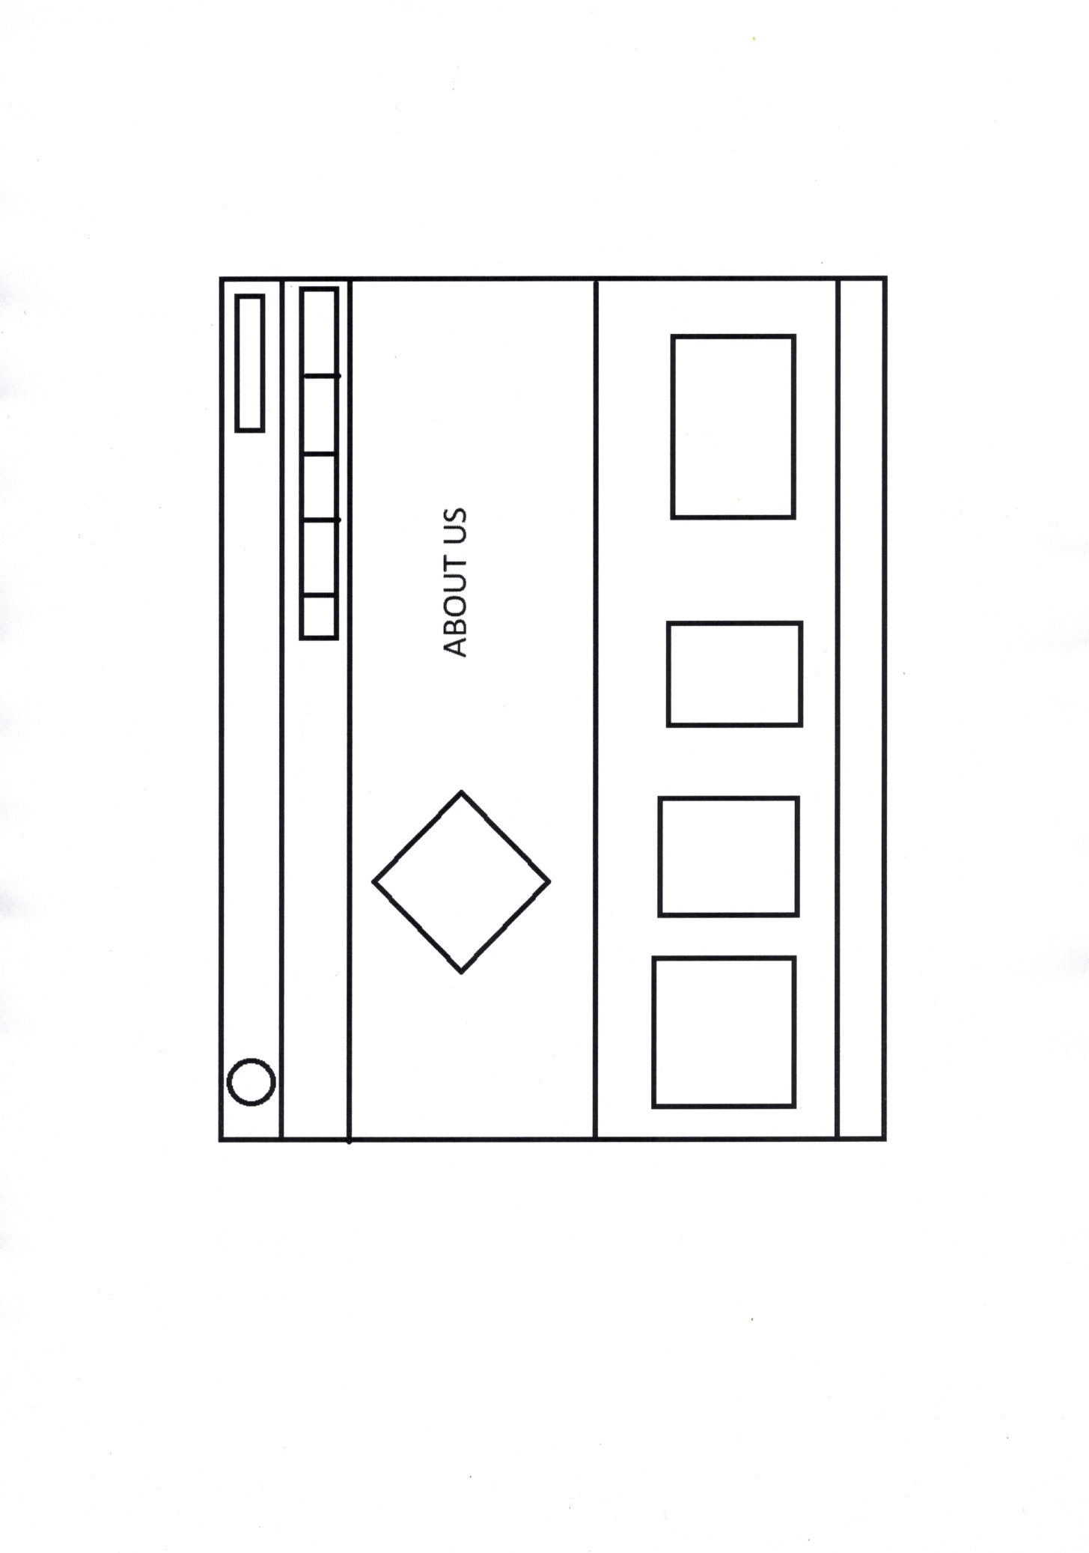

**About Us Page**

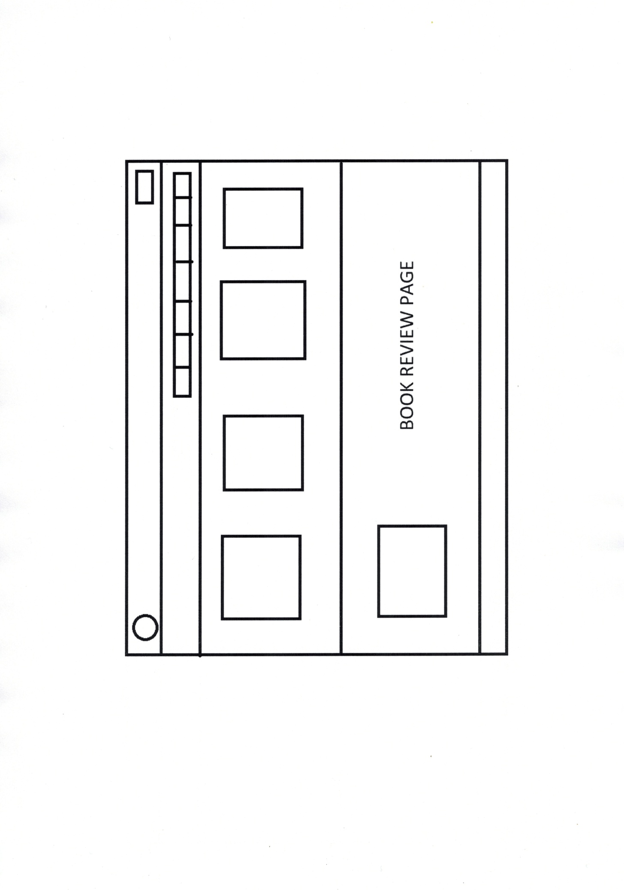

**Book Review Page**

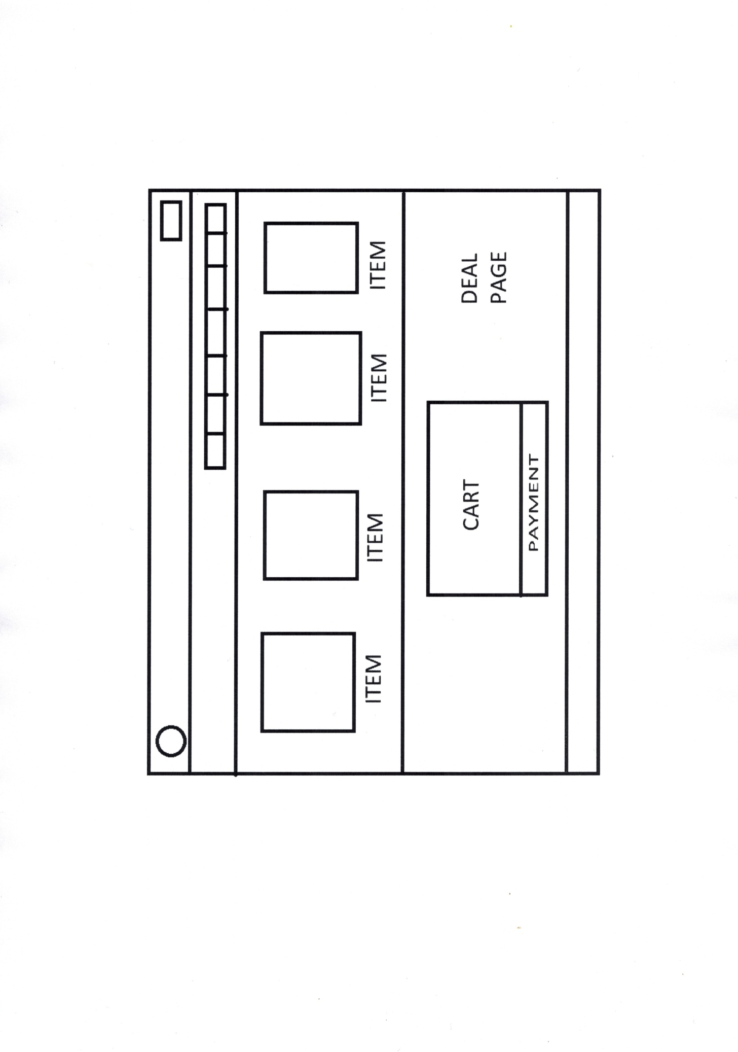

**Shopping Cart**

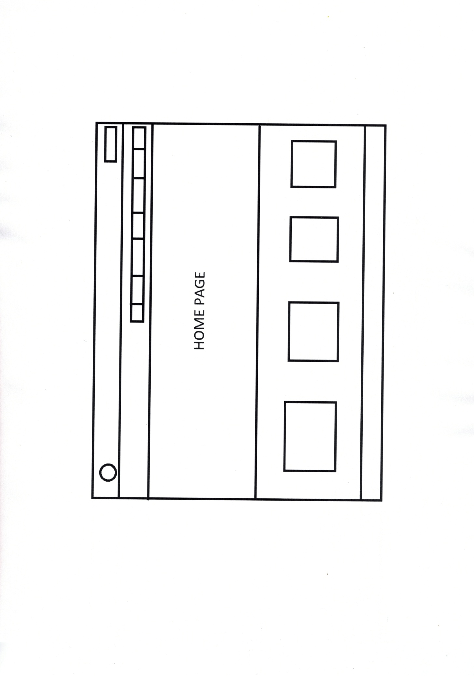

**HOME Page**

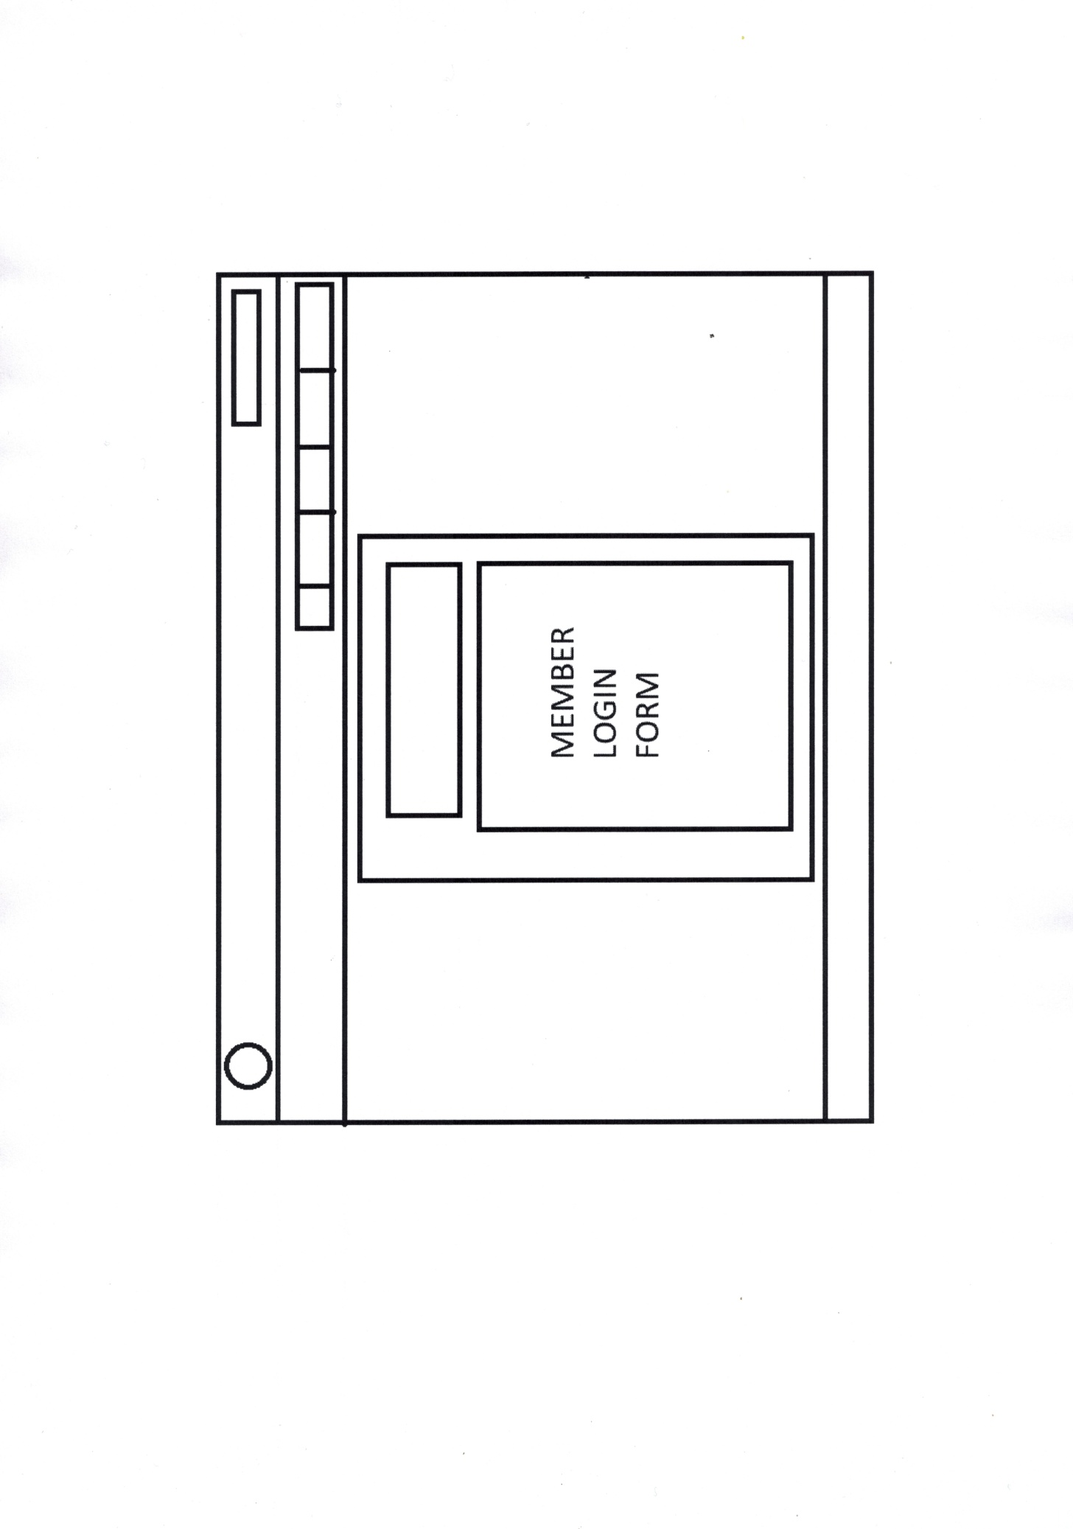

**MEMBER LOGIN FORM**